**DAILY ONLINE ACTIVITIES SUMMARY**

|  |  |  |  |  |  |  |  |  |
| --- | --- | --- | --- | --- | --- | --- | --- | --- |
| **Date:** | **26-05-2020** | | | | | **Name:** | **Kavya** | |
| **Sem & Sec** | **6th & A** | | | | | **USN:** | **4AL17CS041** | |
| **Online Test Summary** | | | | | | | | |
| **Subject** | | **Computer Graphics** | | | | | | |
| **Max. Marks** | | **30** | | **Score** | | | **22** | |
| **Certification Course Summary** | | | | | | | | |
| **Course** | **Python course for Machine Learning** | | | | | | | |
| **Certificate Provider** | | | **GreatLearning** | | **Duration** | | | **5Hours** |
| **Coding Challenges** | | | | | | | | |
| **Problem Statement:1:** Write a program in C to print all permutations of a given string using pointers  2. Given an array A of size N where the array elements contain values from 1 to N with duplicates, the task is to find total number of subarrays which start and end with the same element  **3.** Python Program to Print all Integers that Aren’t Divisible by Either 2 or 3 and Lie between 1 and 50  4. Python Program to Count the Number of Digits in a Number  5. Python Program to Read a Number n And Print the Series "1+2+…..+n= " | | | | | | | | |
| **Status:Yes I have uploaded all the programs in github** | | | | | | | | |
| **Uploaded the report in Github** | | | | | **yes** | | | |
| **If yes Repository name** | | | | | [**https://github.com/kavya-077/DAILY-STATUS**](https://github.com/kavya-077/DAILY-STATUS) | | | |
| **Uploaded the report in slack** | | | | | **yes** | | | |

Online Test Details: (Attach the snapshot and briefly write the report for the same)

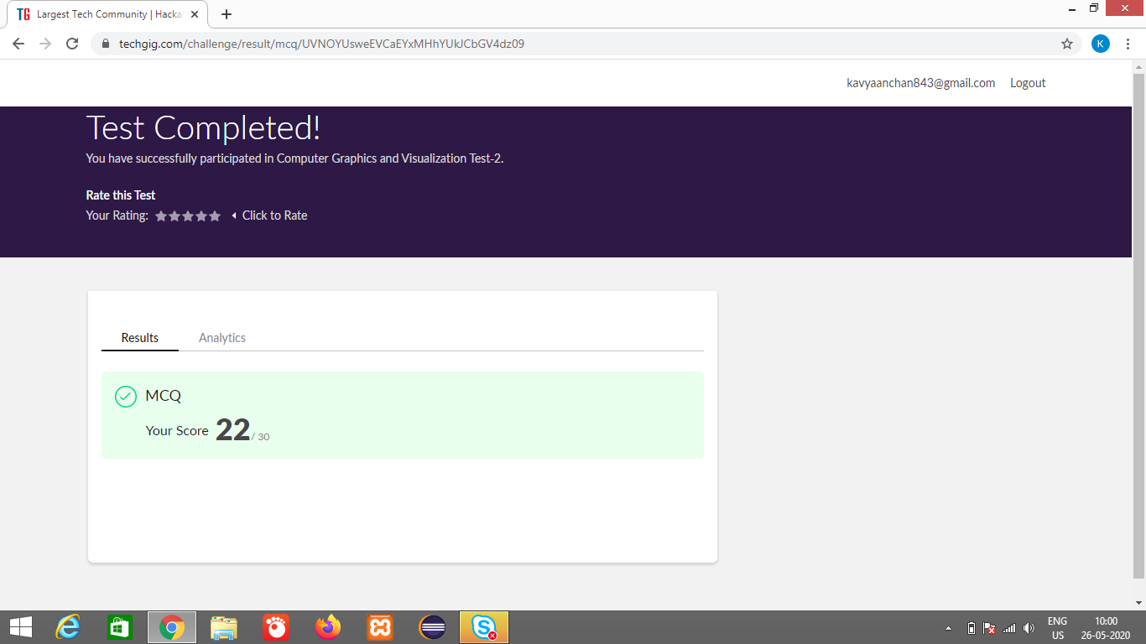

Certification Course Details: (Attach the snapshot and briefly write the report for the same)

Partcipated in the assesement given by course

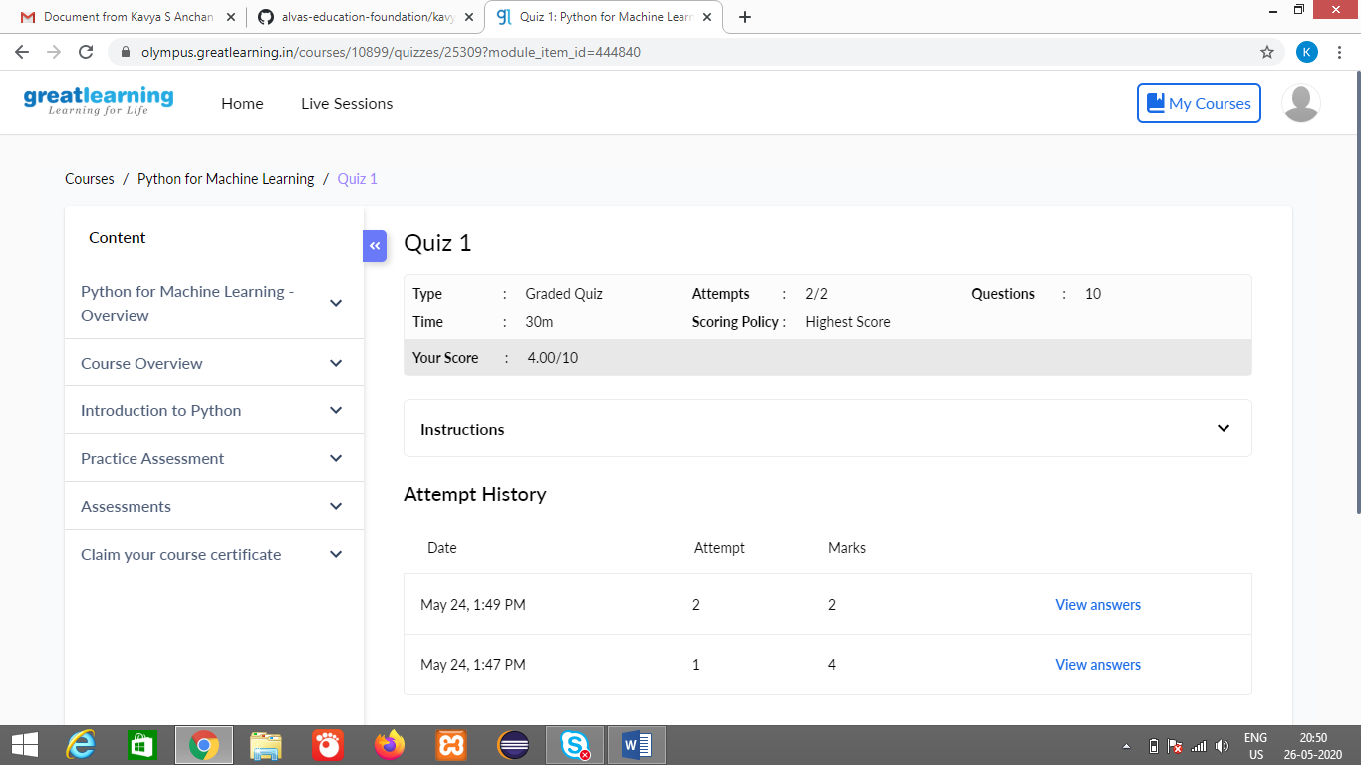

<https://github.com/alvas-education-foundation/kavya-onlinecourse>

Coding Challenges Details: (Attach the snapshot and briefly write the report for the same)

<https://github.com/kavya-077/DAILY-STATUS>

<https://github.com/alvas-education-foundatiom/kavya-OCA>